Precious Inspirations aka Chaplets by Gerri
7232 Sharpsburg Pike
Boonsboro, MD 21713
Chapletsbygerri@gmail.com
301-606-5972

Wrist Rosary Order Form

Name:

Address:

City: _________________________State/Zip Code: ______________

Phone:

Email: ___________________________________________________

Mother's Wrist Rosary $25.00 (standard 5 decades) Add $5.00 for each additional decade. You may personalize each decade with up to 10 letters each or a numerical date.
Names to go on Rosary ___________________________________________________________
______________________________________________________________________________
Names will be put in the decades in the order placed. If only one name, it will be placed in the third decade unless otherwise specified. If no Our Father bead is picked, a Clear Crystal bead will be used.

Item | Cross | Mary Medal | Our Father Bead | Hail Mary Bead | Total
Subtotal
Tax (MD, PA,WV)
Shipping | $9.00
Total
Please Make Payment by Check or PayPal.
Checks to be Made out to Gerri Watkins
PayPal – Chapletsbygerri@gmail.com

Wrist Rosary Order Form
Choose 1 Cross/Crucifix Medal |  | Choose 1 Mary Medal
a | 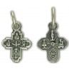 | 1 | 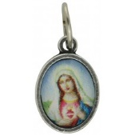
b | 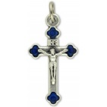 | 2 | 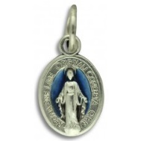
c | 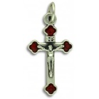 | 3 | 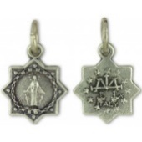
d | 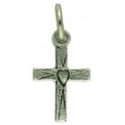 | 4 | 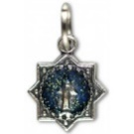
e | 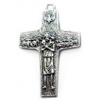 | 5 | 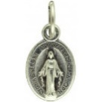
f | 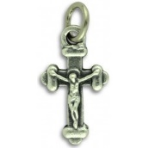 | 6 | 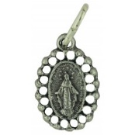
g | 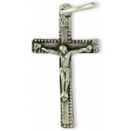 | 7 | 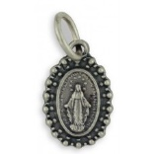
h | 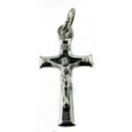 | 8 | 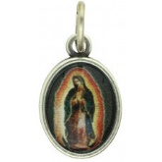
i | 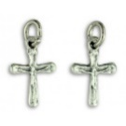 | 9 | 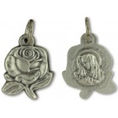

**Beads**

Teal with Blue Iris Finish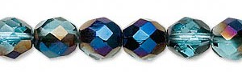 | Teal  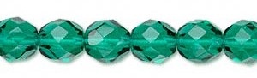
Light Aqua AB  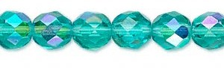 | Emerald Green  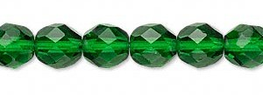
2 Tone Crystal and Aqua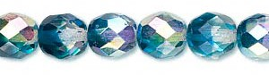 | Saphire Blue  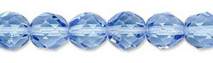
Cobalt  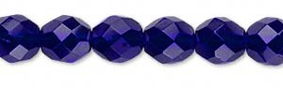 | Amethyst Purple  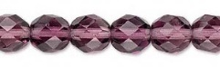
Garnet Red  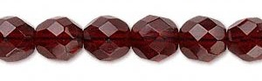 | Ruby Red  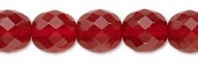
Light Rose AB  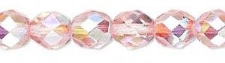 | Light Aqua  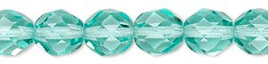
2 Tone Crystal and Green  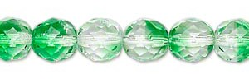 | Emerald Green AB  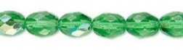
Amethyst Purple AB  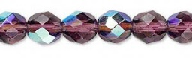 | Dark Aqua  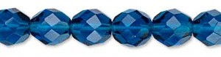
Light Rose
