Precious Inspirations aka Chaplets by Gerri
7232 Sharpsburg Pike
Boonsboro, MD 21713
chapletsbygerri@gmail.com
301‐606‐5972
Personalized/Mother’s Rosary Order Form
Name: _________________________________________________________________
Address: _________________________________________________________________ City: _________________________________________________________________ State/Zip Code: __________________________________________________________________
Phone: Email: _________________________________

Mother’s Rosary $40.00 (standard 5 decades) Add $7.00 for each additional decade. You may personalize each decade with up to 10 letters each or a numerical date
For Seven Decades – A Seven Sorrows of Mary Devotional Medal set will be used unless otherwise specified. Cost $54.00

Rosary #1 | Bead | Personalization – Up to 10 letters or numbers | Crucifix | Center
1st Decade
2nd Decade
3rd Decade
4th Decade
5th Decade
Rosary #2
1st Decade
2nd Decade
3rd Decade
4th Decade
5th Decade
For additional Rosaries or decades, please add to back or on another sheet of paper.
Total # Rosaries | @ $40.00 each
Additional Decades | @ $7.00 each
Tax (MD,PA,WV)
Shipping |  |  |  | $9.00
Total
Please Make Payment by Check or PayPal
Checks to be made payable to Gerri Watkins; PayPal – chapletsbygerri@gmail.com
**Centers**
1.  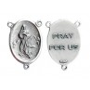 | 2.  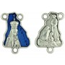 | 3.  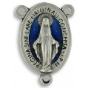 | 4.  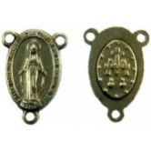
5.  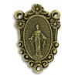 | 6.  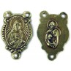 | 7.  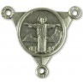 | 8.  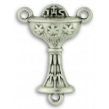
9.  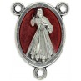 | 10.  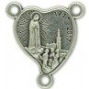 | 11.  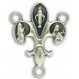 | 12.  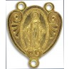
13.  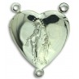 | 14.  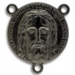 | 15.  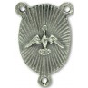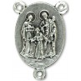 | 16.  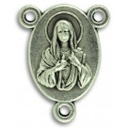
17.  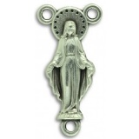 | 18.  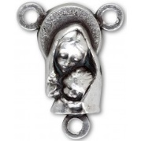 | 19.  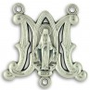 | 20.  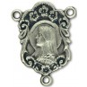
21.  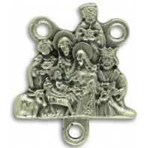 | 22.  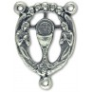 | 23.  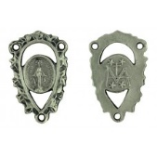 | 24.  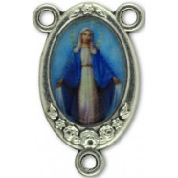
25.  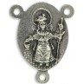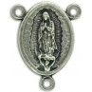 | 26.  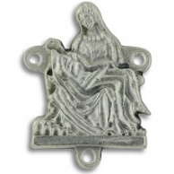 | 27.  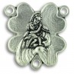 | 28.  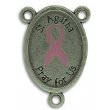
29.  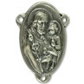 | 30.  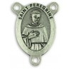 |  | Additional Center Pictures can be found on our website.
**Crucifixes**
a.  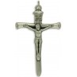 | b.  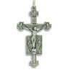 | c.  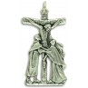 | d.  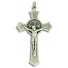
e.  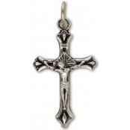 | f.  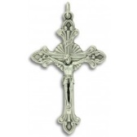 | g.  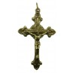 | h.  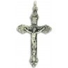
i.  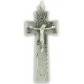 | j.  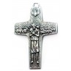 | l.  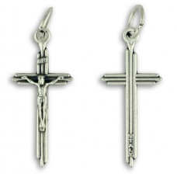 | m.  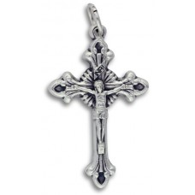
n.  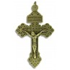 | o.  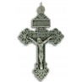 | p.  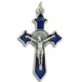 | q.  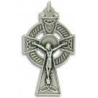
r.  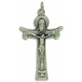 | s.  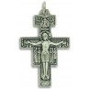 | t.  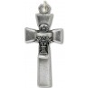 | u.  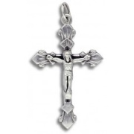
v.  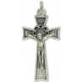 | w.  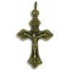 | x.  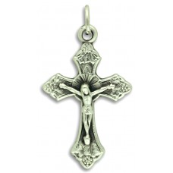 | y.
Z1.  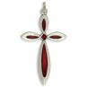 | Z2.  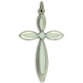 | Z3.  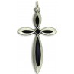 | Additional pictures of Crucifixes and crosses can be found on our website.

**Beads**
Teal with Blue Iris Finish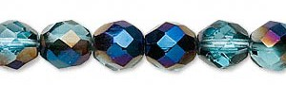 | Teal  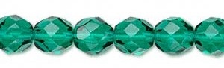
Light Aqua AB  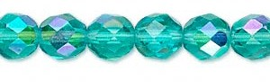 | Emerald Green  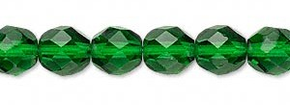
2 Tone Crystal and Aqua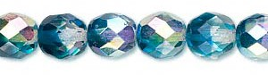 | Saphire Blue  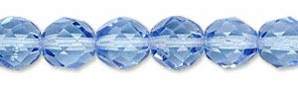
Cobalt  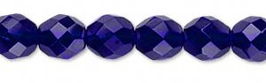 | Amethyst Purple  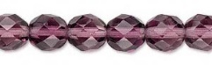
Garnet Red  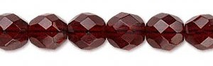 | Ruby Red  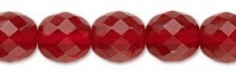
Light Rose AB  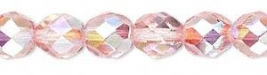 | Light Aqua  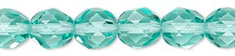
2 Tone Crystal and Green  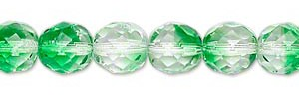 | Emerald Green AB  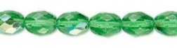
Amethyst Purple AB  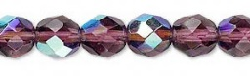 | Dark Aqua  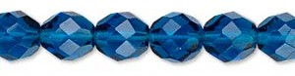
Light Rose
